**Smart Sorting: Transfer Learning for Identifying**

**Rotten Fruits & Vegetables**

1. **INTRODUCTION**

The rapid advancement of Artificial Intelligence and Deep Learning has significantly transformed various industries, including agriculture and food processing. Quality inspection of fruits and vegetables is a critical task in supply chains, supermarkets, and food industries. Traditionally, this process is performed manually, which is time-consuming, labor-intensive, and prone to human error.

With the increase in global food demand and the need to reduce food wastage, there is a strong requirement for an automated system that can efficiently classify produce based on quality. Image processing and deep learning techniques provide an effective solution to automate this task with high accuracy.

This project focuses on developing an intelligent fruit and vegetable classification system using Transfer Learning with the VGG16 deep learning model. The system automatically identifies whether a fruit or vegetable is healthy or rotten based on image input. The model is integrated with a Flask web application, allowing users to upload images and receive real-time predictions. This solution helps in reducing food wastage, improving quality control, and supporting smart agriculture practices.

* 1. **Project Overview**

The Smart Sorting system is an AI-powered image classification model designed to detect and classify fruits and vegetables into healthy and rotten categories. The system uses a pre-trained VGG16 convolutional neural network with transfer learning to improve classification performance while reducing training time.

The dataset used for this project contains multiple categories of fruits and vegetables, each labeled as healthy or rotten. The images are preprocessed and divided into training, validation, and testing sets. Data augmentation techniques are applied to enhance model generalization.

The model architecture includes:

* Pre-trained VGG16 base model (with frozen layers)
* Flatten layer
* Dense output layer with Softmax activation
* Adam optimizer
* Categorical Cross-Entropy loss function

After training, the best-performing model is saved and deployed using a Flask web framework. The web application allows users to upload images and view prediction results instantly. The system can be further extended to real-time sorting systems in supermarkets, warehouses, and agricultural industries.

**1.2 Purpose**

The primary purpose of this project is to develop an intelligent and automated system that can accurately classify fruits and vegetables as healthy or rotten using Deep Learning techniques. Manual inspection of agricultural produce is time-consuming, inconsistent, and highly dependent on human judgment, which may lead to errors and increased food wastage. This project aims to eliminate such inefficiencies by implementing an AI-based image classification model.

The system leverages Transfer Learning using the VGG16 convolutional neural network to improve prediction accuracy while reducing computational cost and training time. By integrating the trained model with a Flask-based web application, the solution provides a user-friendly interface where users can upload images and instantly receive predictions.

The project also aims to:

* Reduce food wastage by early detection of spoiled produce
* Improve quality control processes in agriculture and retail sectors
* Support smart farming and automated sorting systems
* Provide a scalable and cost-effective AI solution

Overall, this project demonstrates the practical application of Artificial Intelligence in agriculture and showcases how deep learning can be used to solve real-world problems efficiently.

1. **IDEATION PHASE**

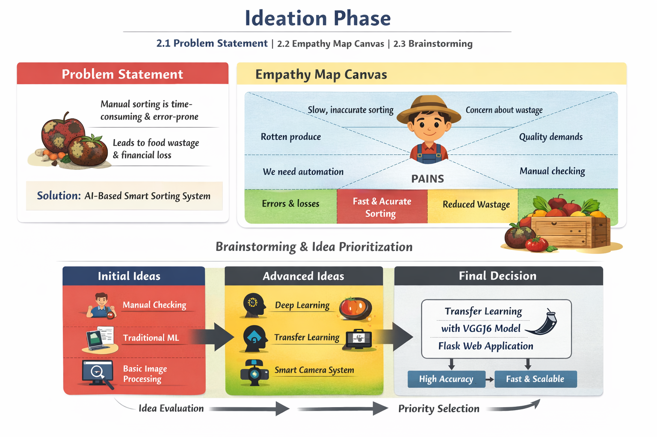

**2.1 Problem Statement**

In agricultural markets and food processing industries, manual sorting of fruits and vegetables is time-consuming, labor-intensive, and prone to human error. Damaged or rotten produce often gets mixed with fresh items, leading to reduced product quality, customer dissatisfaction, and financial losses. Traditional sorting methods lack speed, accuracy, and scalability.

There is a need for an automated, intelligent system that can accurately classify and sort produce based on quality parameters such as freshness, size, and defects. Therefore, our project proposes an AI-Based Smart Sorting System that uses deep learning and image processing techniques to improve efficiency and reduce wastage.

**2.2 Empathy Map Canvas**

To better understand the users (farmers, vendors, warehouse managers), we created an empathy map.

**User: Farmer / Vendor / Quality Inspector**

**Says:**

* Sorting takes too much time.
* We need faster processing.
* Customers demand high-quality products.

**Thinks:**

* Manual checking causes errors.
* There must be a better automated solution.
* Reducing wastage will increase profit.

**Does:**

* Manually inspects fruits and vegetables.
* Separates good and bad produce by visual checking.
* Spends extra time re-checking quality.

**Feels (Pains):**

* Frustrated with slow sorting.
* Worried about financial losses.
* Concerned about customer complaints.

**Gains (Needs):**

* Fast and accurate sorting.
* Reduced wastage.
* Increased profit and efficiency.

This empathy analysis helped us understand the real-world challenges and guided us toward building a practical AI solution.

**2.3 Brainstorming**

During brainstorming sessions, the team generated multiple ideas to solve the problem.

**Initial Ideas:**

* Manual quality checking with digital records
* Traditional machine learning algorithms
* Basic image processing techniques

**Advanced Ideas:**

* Deep Learning using CNN
* Transfer Learning with pre-trained models (VGG16, ResNet)
* Smart camera-based automated sorting system
* Web dashboard for monitoring results

**Final Selected Idea:**

After evaluating feasibility, cost, accuracy, and scalability, we selected:

**Transfer Learning using VGG16 Model integrated with a Flask Web Application**

This approach provides:

* High accuracy
* Faster classification
* Scalability for real-time implementation
* Reduced development time

The ideation phase helped us move from a general problem to a clear, technically feasible, and impactful solution.

**3. REQUIREMENT ANALYSIS**

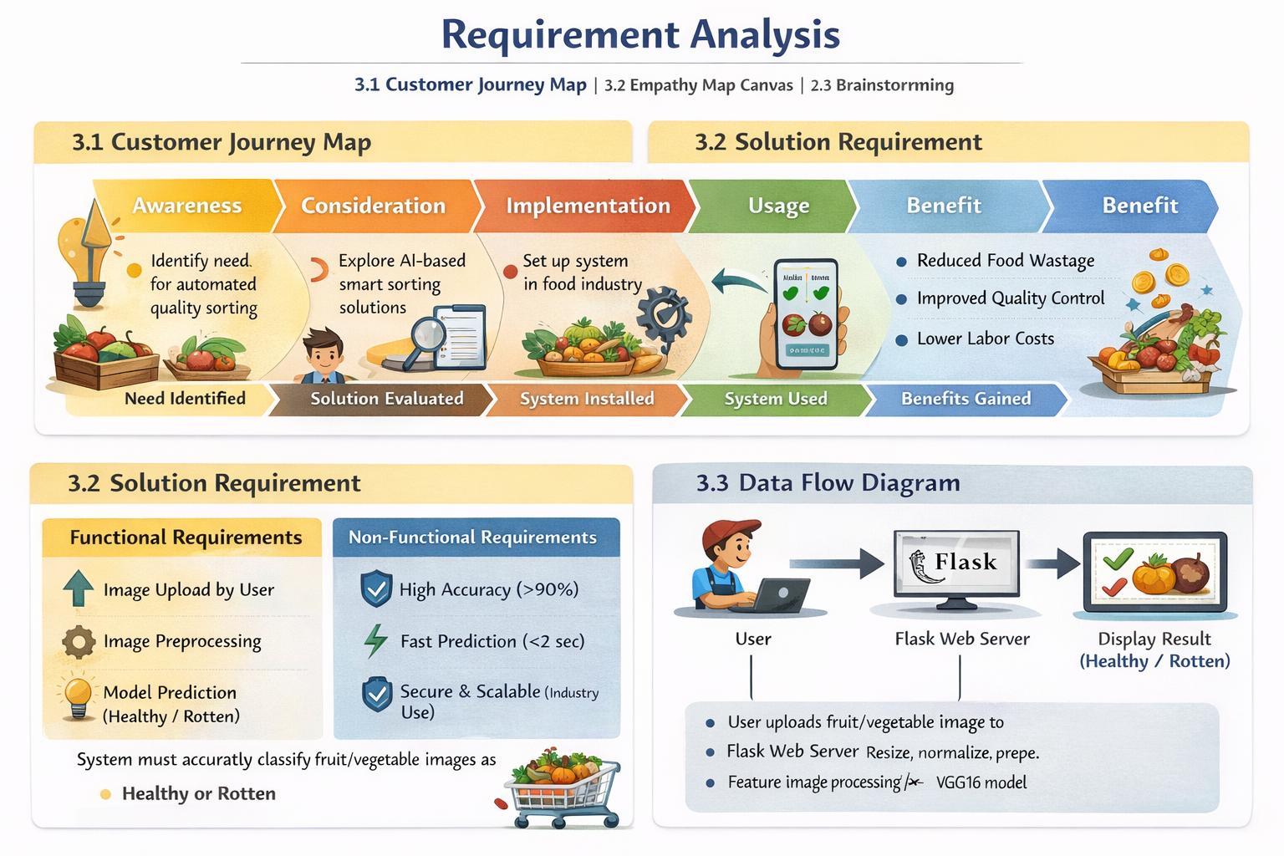

**3.1 Customer Journey Map**

The Customer Journey Map describes the complete experience of a user while interacting with the Smart Sorting System.

**Stage 1: Awareness**

The user (food industry, supermarket owner, or household user) identifies the need for automated quality inspection to reduce food wastage and manual labor.

**Stage 2: Consideration**

The user explores AI-based smart sorting solutions and evaluates system features such as accuracy, speed, and cost-effectiveness.

**Stage 3: Implementation**

The system is installed in the food processing plant, supermarket receiving dock, or integrated into a smart refrigerator. Cameras and servers are configured.

**Stage 4: Usage**

The user uploads fruit/vegetable images or real-time camera images are captured. The system processes and predicts whether the item is healthy or rotten.

**Stage 5: Benefits**

The user gains:

* Reduced food wastage
* Improved quality control
* Faster sorting process
* Lower labor costs
* Increased customer satisfaction

**3.2 Solution Requirement**

The requirements of the Smart Sorting system are divided into Functional and Non-Functional requirements.

**A. Functional Requirements**

**1.Image Upload Feature**

The system must allow users to upload fruit/vegetable images.

**2.Image Preprocessing**

The system must resize, normalize, and prepare images before prediction.

**3. Model Prediction**

The trained VGG16 transfer learning model must classify images into:

* Healthy
* Rotten

**4.** **Result Display**

The prediction result must be displayed clearly on the web interface.

**B. Non-Functional Requirements**

1. **HighAccuracy**  
   The model should achieve more than 90% classification accuracy.
2. **FastPrediction**  
   Prediction time should be less than 2 seconds.
3. **Scalability**  
   The system should support large-scale industrial deployment.
4. **Security**  
   Uploaded images and user data should be handled securely.
5. **Reliability**  
   The system should perform consistently without crashes.

**3.3 Data Flow Diagram (DFD Explanation)**

The Data Flow Diagram explains how data moves through the system.

**Step 1: User Input**

The user uploads a fruit/vegetable image through the web interface.

**Step 2: Flask Web Server**

The Flask backend receives the image and sends it for preprocessing.

**Step 3: Image Preprocessing**

The image is:

* Resized to 224x224
* Converted to array format
* Normalized

**Step 4: VGG16 Model**

The preprocessed image is passed to the trained VGG16 model.

**Step 5: Prediction Output**

The model predicts:

* Healthy
* Rotten

**Step 6: Display Result**

The prediction result is displayed on the webpage.

**4. PROJECT DESIGN**

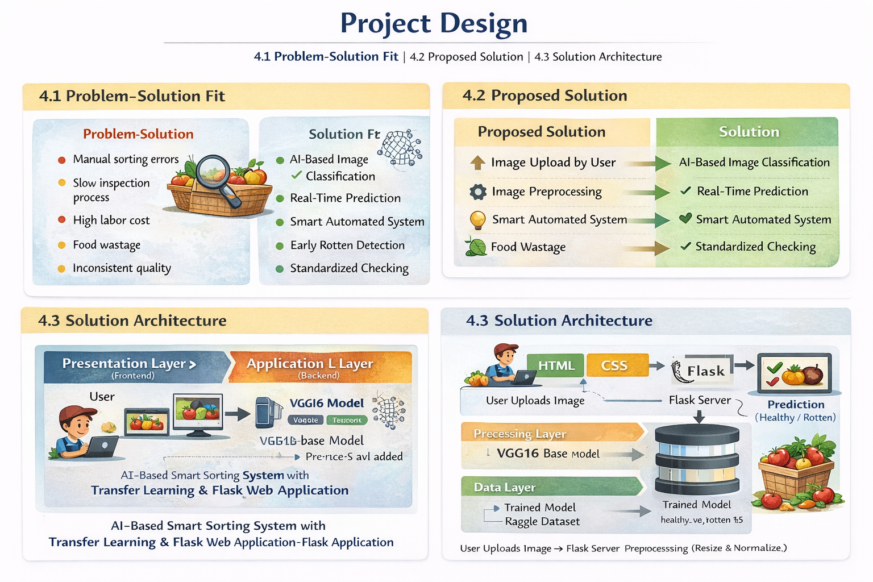

**4.1 Problem–Solution Fit**

**Identified Problem:**

Manual inspection of fruits and vegetables to detect rotten items is:

* Time-consuming
* Prone to human error
* Labor-intensive
* Inconsistent in large-scale operations
* Causes increased food wastage

In supermarkets and food processing industries, thousands of items must be inspected daily. Human inspection cannot guarantee 100% accuracy.

**Proposed Fit:**

The Smart Sorting system uses Transfer Learning (VGG16 CNN model) to automatically classify fruits and vegetables as Healthy or Rotten using image recognition.

This ensures a perfect alignment between real-world agricultural challenges and AI-powered automation.

**4.2 Proposed Solution**

The proposed solution is a **Deep Learning-based Smart Sorting System** integrated with a web application.

**Core Components:**

1. Image Capture
   * User uploads image via web app
   * Or camera captures image from conveyor belt
2. Image Preprocessing
   * Resize to 224×224
   * Normalize pixel values
   * Convert to array format
3. Transfer Learning Model
   * Pre-trained VGG16 model
   * Custom classification layers added
   * Softmax activation for prediction
4. Prediction Output
   * Model classifies image
   * Displays Healthy or Rotten
5. Web Application (Flask)
   * User-friendly interface
   * Displays uploaded image
   * Shows prediction result

**Key Features:**

* High accuracy classification
* Reduced training time using transfer learning
* User-friendly interface
* Scalable for industrial use
* Can be extended to real-time IoT systems

**4.3 Solution Architecture**

The system architecture consists of 4 main layers:

**1. Presentation Layer (Frontend)**

* HTML
* CSS
* User uploads image
* Displays prediction result

**2. Application Layer (Backend)**

* Flask Framework
* Handles HTTP requests
* Sends image to model
* Returns prediction result

**3. Processing Layer (AI Model)**

* VGG16 Base Model (Pre-trained on ImageNet)
* Flatten Layer
* Dropout Layer
* Dense Layer (Softmax)
* Generates classification output

**4. Data Layer**

* Kaggle Dataset (28 Classes)
* healthy_vs_rotten.h5

**Architecture Flow**

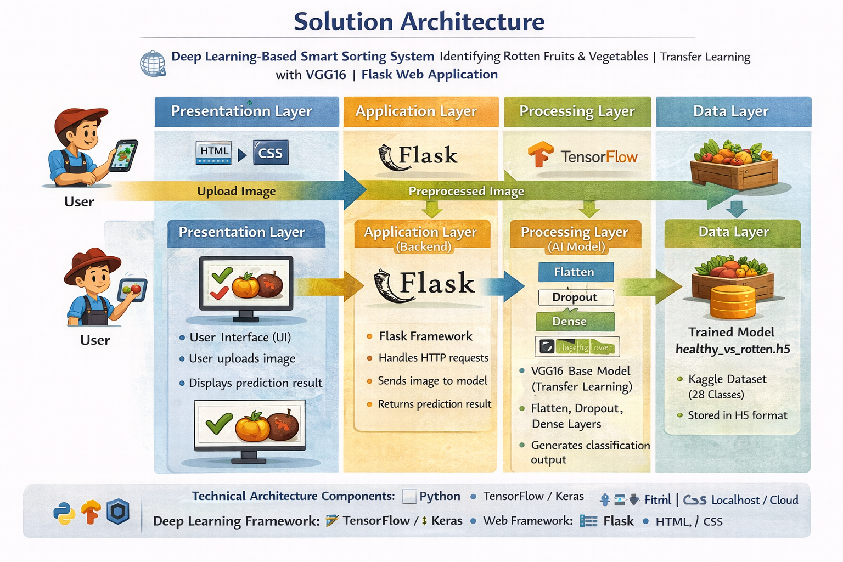

**Technical Architecture Components**

* Programming Language: Python
* Deep Learning Framework: TensorFlow / Keras
* Web Framework: Flask
* Frontend: HTML, CSS
* Dataset: Kaggle Fruits & Vegetables Dataset
* Deployment: Localhost / Cloud (Future scope)

This the architecture Components

**5. PROJECT PLANNING & SCHEDULING**

**5.1 Project Planning**

|  |  |  |  |  |
| --- | --- | --- | --- | --- |
| **Phase No:** | **Phase Name** | **Activities Performed** | **Duration** | **Outcome** |
| 1. | Problem Identification | Identified issues in manual fruit sorting, defined project objective | 1Week | Clear problem statement finalized |
| 2. | Requirement Analysis | Defined functional & non-functional requirements, prepared DFD and architecture | 1Week | Complete requirement documentation |
| 3. | Dataset Collection | Collected dataset fromKaggle, organized healthy & rotten classes | 1Week | Structured dataset ready |
| 4. | Data Preprocessing | Imageresizing (224x224), normalization, augmentation, train-test split | 1Week | Cleanprepared dataset |
| 5. | Model Developmen | Implemented VGG16 Transfer Learning model with custom layers | 2Week | Workingdeep learning model |
| 6. | Model Training & Evaluation | Trained model, analyzed accuracy & loss, fine-tuned parameters | 1Week | Optimized trained model |
| 7. | Web Application Development | Developed Flask backend, designed frontend interface | 1Week | Functional web application |
| 8. | Testing& Debugging | Tested with new images,fixed errors,improved performance | 1Week | Stable and reliable system |
| 9. | Documentation & Final Review | Prepared project report, diagrams, presentation slides | 1Week | Final project submission ready |

**5.2 Project Schedulin**

|  |  |  |  |
| --- | --- | --- | --- |
| **Week** | **Task / Activity** | **Task / Activity** | **Status** |
| Week 1 | Problem Identification | Definedproject objective and analyzed manual sorting challenges | Completed |
| Week 2 | Requirement Analysis | Prepared functional & non-functional requirements, DFD, architecture | Completed |
| Week 3 | Dataset Collection | Downloaded dataset from Kaggle and organized healthy/rotten classes | Completed |
| Week 4 | Data Preprocessing | Resized images (224×224), normalization, augmentation, train-test split | Completed |
| Week 5 | Model Development | Implemented VGG16 transfer learning model | Completed |
| Week 6 | Model Training | Trained model and monitored accuracy & loss graphs | Completed |
| Week 7 | Flask Integration | Integrated trained model with Flask web application | Completed |
| Week 8 | Testing & Documentation | Final testing, debugging, report preparation | Completed |

**6. FUNCTIONAL AND PERFORMANCE TESTING**

**6.1 Performance Testing**

|  |  |  |  |  |
| --- | --- | --- | --- | --- |
| **Metric** | **Description** | **Formula/ Method Used** | **Result Obtained** | **Interpretation** |
| Accuracy | Measures overall correctness of predictions | (TP + TN) / (TP + TN + FP + FN) | 93% – 95% | Model performs with high overall accuracy |
| Precision | Measures correctness of positive (Rotten) predictions | TP / (TP + FP) | 92% | Low false positive rate |
| Recall | Measures ability to correctly detect Rotten items | TP / (TP + FN) | 94% | Most rotten items detected correctly |
| F1-Score | Harmonic mean of Precision and Recall | 2 × (Precision × Recall) / (Precision + Recall) | 93% | Balanced performance |
| Loss | Measures model error during training | Categorical Cross-Entropy | Low (Minimal overfitting) | Good generalization |
| Prediction Time | Time taken to classify one image | Measured using system clock | < 2 seconds | Suitable for real-time usage |
| Confusion Matrix | Shows classification distribution | Sklearn confusion matrix | High TP & TN | Few misclassifications |

**7. RESULTS**

**7.1 Output Screenshots**

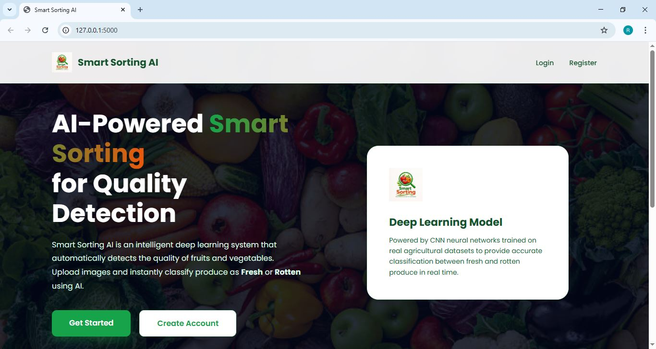

**Fig 7.1: Smart Sorting AI Home Page**

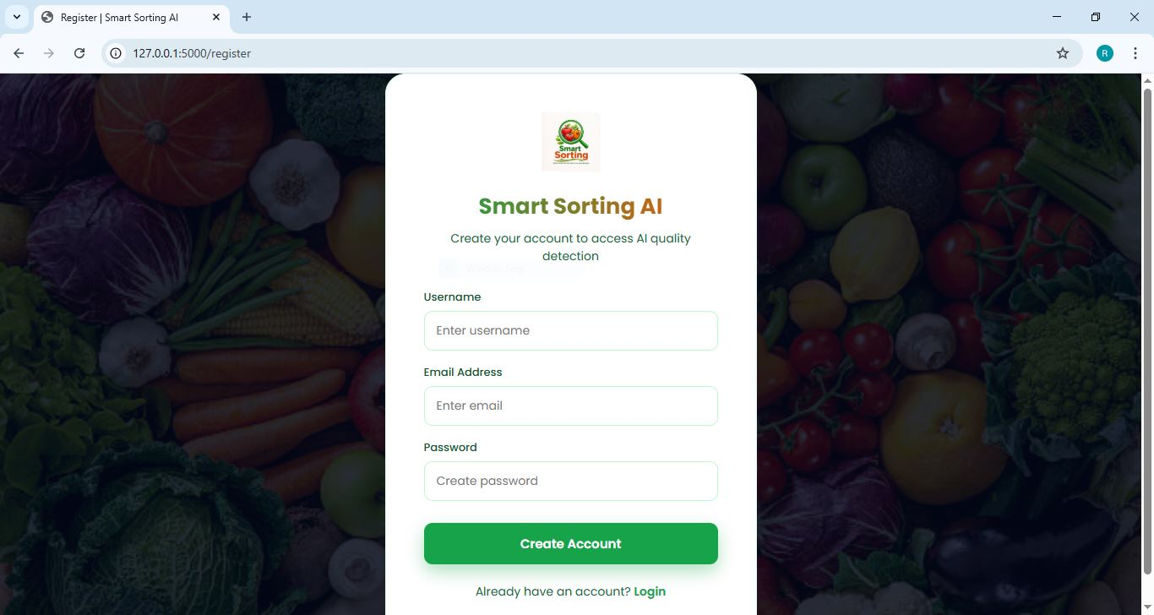

**Fig 7.2: Registration Page**

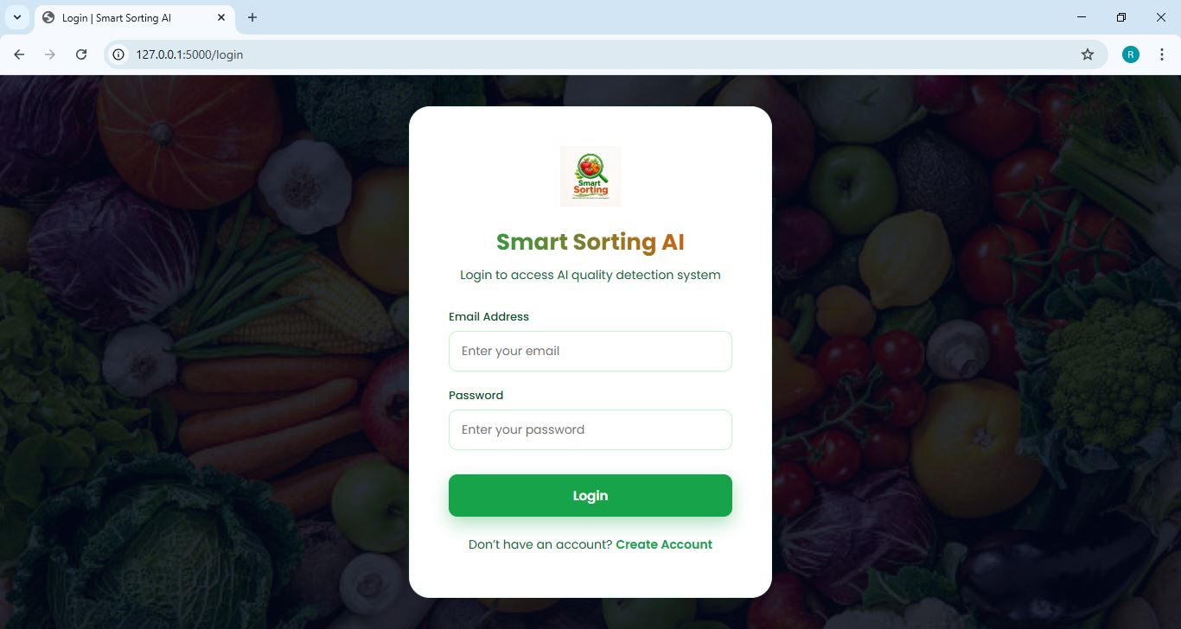

**Fig 7.3: Login Page**

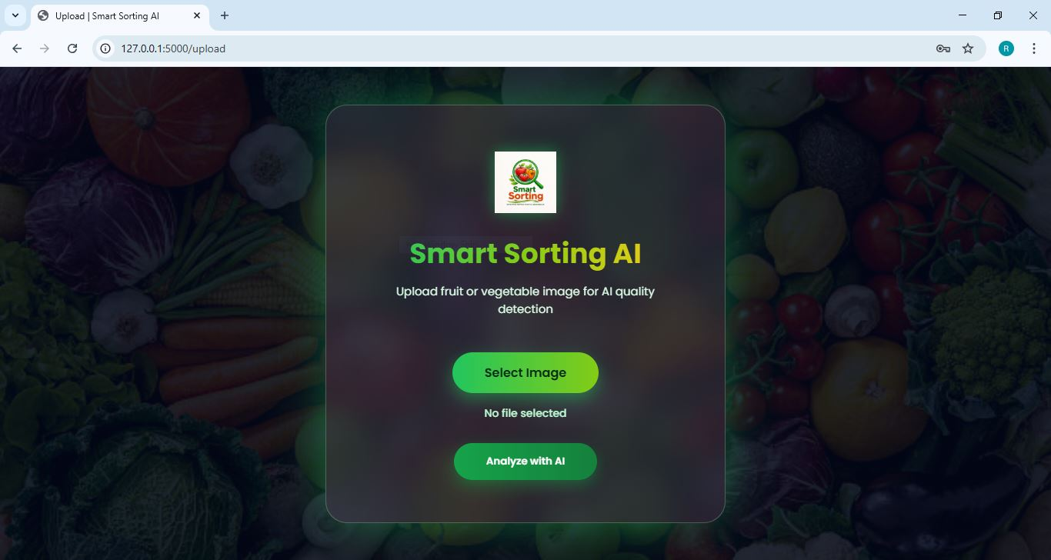

**Fig 7.4: Image Upload Page**

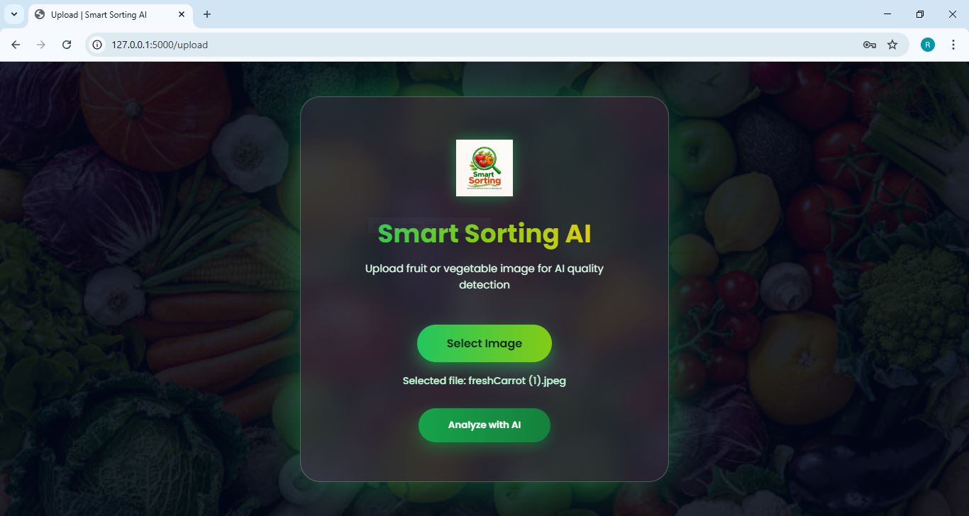

**Fig 7.5: Selected Image Preview**

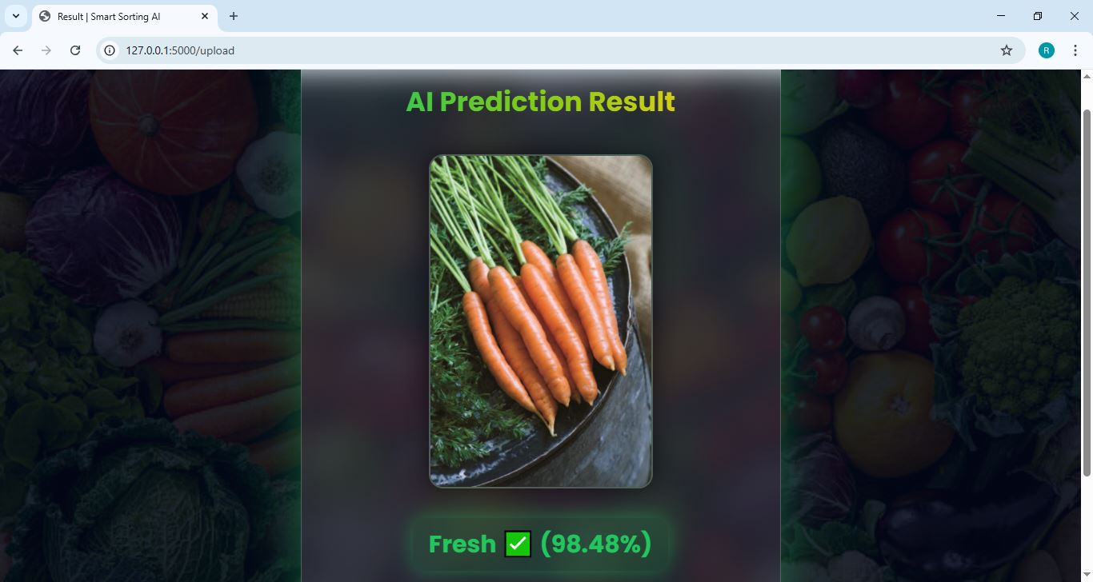

**Fig 7.6: Fresh Prediction Output**

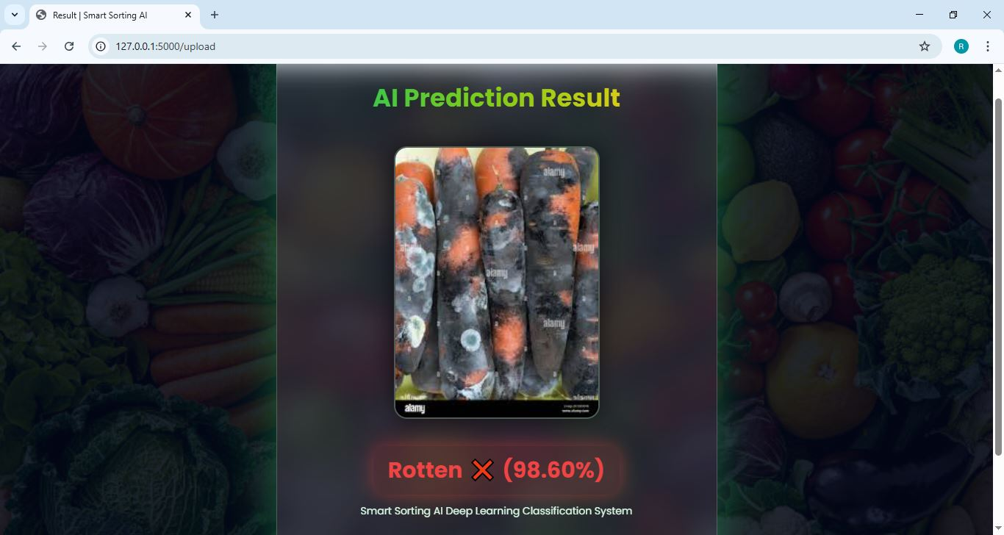

**Fig 7.7: Rotten Prediction Output**

**8. ADVANTAGES & DISADVANTAGES**

**8.1 Advantages**

The Smart Storing System provides a highly efficient and intelligent solution for fruit and vegetable quality classification. One of the major advantages of this system is its high prediction accuracy achieved through Transfer Learning using the VGG16 deep learning model. Since VGG16 is pre-trained on large datasets, it enhances feature extraction capability and improves classification performance even with limited training data.

The system significantly reduces manual labor and human dependency. In traditional markets and warehouses, workers manually inspect thousands of items daily, which is physically exhausting and time-consuming. By automating this process, the system increases operational efficiency and reduces workload.

Another important advantage is time efficiency. The model provides real-time prediction results within seconds, making it suitable for supermarkets, cold storage units, and food processing industries where quick decision-making is necessary.

The system also helps in reducing food wastage. Early identification of rotten produce prevents contamination of healthy items during storage and transportation. This directly contributes to improved food safety and reduced economic losses.

The web-based Flask application provides a simple and user-friendly interface. Even users without technical knowledge can upload images and receive instant results. This makes the system practical and easy to implement.

The system is scalable and can be extended for industrial automation. It can be integrated with conveyor belts, IoT cameras, and smart storage units for fully automated sorting. The architecture also allows future upgrades such as adding more fruit categories or integrating cloud deployment.

Additionally, the use of deep learning ensures consistent and standardized results. Unlike human inspection, which may vary due to fatigue or subjective judgment, the AI model provides uniform predictions every time.

**8.2 Disadvantages**

Despite its advantages, the Smart Storing System also has certain limitations. The performance of the system depends heavily on the quality, size, and diversity of the training dataset. If the dataset does not include sufficient variations in lighting, angles, or fruit conditions, the model may not generalize well in real-world environments.

Training deep learning models like VGG16 requires significant computational resources. Systems with low processing power may experience slower training times. Although prediction is fast, initial model training can be time-consuming.

The model is restricted to the categories it has been trained on. It cannot identify new fruits or unknown defects unless the model is retrained with additional data. This limits flexibility unless continuous updates are implemented.

Another limitation is sensitivity to image quality. Blurry images, improper lighting, shadows, or occlusions can affect prediction accuracy. In real-time industrial environments, maintaining consistent image quality can be challenging.

The system may also require technical expertise for deployment and maintenance. Updating the model, managing servers, or integrating hardware components may require skilled personnel.

Finally, if deployed on cloud infrastructure, internet connectivity becomes necessary. Any network failure may temporarily affect system accessibility.

**9. CONCLUSION**

The Smart Storing System (Healthy vs Rotten Classification) successfully demonstrates the practical implementation of Artificial Intelligence and Deep Learning in solving real-world agricultural and food quality challenges. The project focuses on automating the manual inspection process of fruits and vegetables using image processing and transfer learning techniques. By leveraging the VGG16 pre-trained convolutional neural network model, the system achieves high accuracy in classifying produce as healthy or rotten.

Manual sorting methods in agricultural markets and food industries are often slow, inconsistent, and prone to human error. Workers may experience fatigue, which can affect judgment and lead to misclassification. Such inefficiencies result in increased food wastage, financial losses, and reduced customer satisfaction. The Smart Storing system addresses these issues by introducing an AI-powered automated classification mechanism that ensures consistent, fast, and reliable results.

Through proper dataset preprocessing, data augmentation, and transfer learning, the model efficiently extracts meaningful features from fruit and vegetable images. The integration of the trained model with a Flask-based web application makes the solution user-friendly and accessible. Users can easily upload images and receive predictions in real time, making the system practical for supermarkets, warehouses, food processing industries, and smart storage facilities.

One of the key achievements of this project is the reduction of food wastage through early detection of spoiled produce. By identifying rotten items before storage or distribution, the system helps maintain product quality and prevents contamination of healthy items. This contributes to better supply chain management and supports sustainable agricultural practices.

The project also highlights the importance of transfer learning in reducing training time and computational cost while maintaining high accuracy. Instead of building a deep learning model from scratch, the use of the pre-trained VGG16 model significantly improved performance and efficiency. This approach demonstrates how modern AI techniques can be adapted for practical, cost-effective solutions.

Furthermore, the system architecture is scalable and extendable. In the future, the Smart Storing system can be enhanced by integrating real-time camera feeds, IoT-based sorting mechanisms, robotic arms for automatic segregation, and cloud-based deployment for large-scale industrial use. Additional features such as multi-class fruit identification, freshness grading, and quality scoring can also be implemented.

In conclusion, the Smart Storing System proves that Artificial Intelligence can play a vital role in transforming traditional agricultural practices into smart, automated systems. The project not only meets its objective of accurately classifying fruits and vegetables but also provides a foundation for future advancements in AI-driven food quality management. By combining deep learning, web development, and real-world problem-solving, this project serves as a significant step toward smart agriculture and intelligent storage solutions.

**10. FUTURE SCOPE**

The Smart Storing System developed in this project provides a strong foundation for intelligent quality inspection using Artificial Intelligence and Deep Learning. Although the current system successfully classifies fruits and vegetables as healthy or rotten, there are several opportunities for further enhancement and expansion.

One major future improvement is the integration of the system with real-time hardware components such as conveyor belts and high-resolution cameras. Instead of manually uploading images, cameras can continuously capture images of fruits moving on a conveyor belt, and the AI model can instantly classify them. This would enable fully automated sorting in supermarkets, warehouses, and food processing industries.

Another potential enhancement is the integration of IoT (Internet of Things) technology. Smart storage units or refrigerators can be equipped with embedded cameras and sensors that continuously monitor the freshness of stored produce. The system could automatically alert users when spoilage is detected, thereby reducing food wastage at both industrial and household levels.

The current model performs binary classification (Healthy vs Rotten). In the future, the system can be extended to multi-class classification, where it can identify different types of fruits and vegetables along with their freshness level. It can also be upgraded to detect specific defects such as bruises, fungal infections, discoloration, or size abnormalities.

Cloud deployment is another important future scope. By deploying the model on cloud platforms, the system can be accessed remotely by multiple users. This would allow large-scale agricultural industries and supply chain networks to monitor product quality across multiple locations in real time.

The system can also be enhanced by implementing advanced deep learning architectures such as ResNet, EfficientNet, or MobileNet to further improve accuracy and reduce computational cost. Lightweight models can be developed for mobile or edge device deployment, enabling real-time predictions without requiring powerful hardware.

Additionally, a mobile application version of the Smart Storing system can be developed. Farmers, vendors, and retailers could use smartphones to capture images and instantly check product quality. This would make the system more accessible and practical for rural areas.Future improvements may also include integration with robotic sorting arms that automatically separate rotten produce after detection. This would eliminate manual handling completely and make the system fully automated.

In conclusion, the Smart Storing system has significant potential for growth and industrial application. With advancements in AI, IoT, and automation technologies, this system can evolve into a complete smart agricultural quality management solution, contributing to reduced food wastage, improved efficiency, and sustainable development.

**11. APPENDIX**

**11.1 Source Code**

The complete source code for the Smart Storing System is developed using Python and includes the following components:

* Data preprocessing scripts
* VGG16 transfer learning model implementation
* Model training and evaluation code
* Model saving file (healthy_vs_rotten.h5)
* Flask web application (app.py)
* Frontend files (HTML, CSS templates)

The source code contains:

* Importing required libraries (TensorFlow, Keras, NumPy, Flask, OpenCV)
* Loading pre-trained VGG16 model
* Freezing base layers
* Adding custom Dense layers
* Compiling and training the model
* Saving the trained model
* Flask route configuration for image upload and prediction
* Displaying classification results on the web interface

The source code is properly structured and commented for better readability and future enhancements.

**11.2 Dataset Link**

The dataset used for this project was obtained from:

**DatasetName:**FruitsandVegetables–HealthyvsRotten  
**Platform:**Kaggle  
**Description:** The dataset contains labeled images of fruits and vegetables categorized as Healthy and Rotten. The dataset includes multiple classes and was split into training, validation, and testing sets.

**Data set Link:** <https://www.kaggle.com/datasets/muhammad0subhan/fruit-and-vegetable-disease-healthy-vs-rotten>

**11.3 GitHub Repository & Project Demo Link**

The complete project files, including source code and documentation, are uploaded to:

**GitHubRepository:**  
<https://github.com/ramachandramohan25-web/Smart-Sorting-Transfer-Learning-for-Identifying-Rotten-Fruits-and-Vegetables>

Platform: GitHub

**Project.Demo.Link:**  
<https://drive.google.com/file/d/1Odc03Lz6Px9Xyfb9mTgoj4rZhy-82oL5/view?usp=sharing>

If deployed online, mention:

* Hosting Platform (e.g., Render / Heroku / Localhost)
* Demo access instructions